**Create a custom Teams policy**

1. In the left navigation of the Microsoft Teams admin center, go to **Teams** > **Teams policies**.
2. Click **Add**.
3. Enter a name and description for the policy.

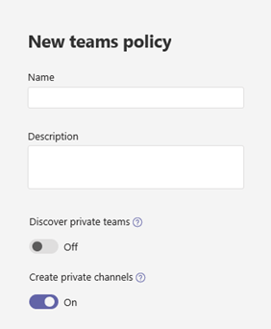

1. Choose the settings that you want:

* **Discover private teams**: Turn on this setting to allow users to discover private teams in search results and in the team gallery.
* **Create private channels**: Turn on this setting to allow users to create private channels.

1. Click **Save**.

**Edit a Teams policy**

You can edit the global policy or any custom policies that you create.

1. In the left navigation of the Microsoft Teams admin center, go to **Teams** > **Teams policies**.
2. Select the policy by clicking to the left of the policy name, and then click **Edit**.
3. Turn on or turn off the settings that you want, and then click **Save**.

**Assign a custom Teams policy to users**

You can use the Microsoft Teams admin center to assign a custom policy to one or more users or the Skype for Business PowerShell module to assign a custom policy to groups of users, such as a security group or distribution group.

**Assign a custom Teams policy to users**

To assign a policy to one user:

1. In the left navigation of the Microsoft Teams admin center, go to **Users**, and then click the user.
2. Click **Policies**, and then next to **Assigned policies**, click **Edit**.
3. Under **Teams policies**, select the policy you want to assign, and then click **Save**.

To assign a policy to multiple users at a time:

1. In the left navigation of the Microsoft Teams admin center, go to **Users**, and then search for the users or filter the view to show the users you want.
2. In the **✓** (check mark) column, select the users. To select all users, click the ✓ (check mark) at the top of the table.
3. Click **Edit settings**, make the changes that you want, and then click **Apply**.

Or, you can also do the following:

1. In the left navigation of the Microsoft Teams admin center, go to **Teams** > **Teams policies**.
2. Select the policy by clicking to the left of the policy name.
3. Select **Manage users**.
4. In the **Manage users** pane, search for the user by display name or by user name, select the name, and then select **Add**. Repeat this step for each user that you want to add.
5. When you're finished adding users, click **Save**.

**PowerShell comments**

Step 1: Follow *Lab-Powershell-Execute PowerShell commands for Microsoft Teams.docx*

**Step 2:**

* Get the GroupObjectId of the particular group.

$group = Get-AzureADGroup -SearchString "Contoso Marketing"

* Get the members of the specified group.

$members = Get-AzureADGroupMember -ObjectId $group.ObjectId -All $true | Where-Object {$_.ObjectType -eq "User"}

* Assign all users in the group to a particular teams policy. In this example, it's Marketing Teams Policy.

$members | ForEach-Object { Grant-CsTeamsChannelsPolicy -PolicyName "Marketing Teams Policy" -Identity $_.UserPrincipalName}